**Spire LoRaWAN RF  OneDrop & SpiRely**

**AMI Residential & Commercial Water meters**

**Industry Leading Innovation**

The OneDrop and Spirely Smart Water Meters for Advanced Meter Infrastructure (AMI) are a leading industry innovation with long range LoRaWAN RF design technology featuring no external connecting wires or antennas. The OneDrop and Spirely Water Meters are LoRaWAN wireless smart IoT meters.

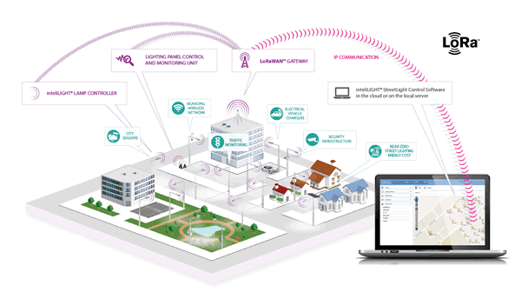There is 2-way, time-synchronized RF protocol to. The OneDrop & SpiRely Water Meters AMI Fixed Network architecture offers exceptional RF range. The OneDrop and Spirely Water Meters offer an extended range up to 2 Miles line of Site to the Gateway bi-directional receivers. OneDrop and Spirely Water Meters are engineered to allow AMR drive-by mode in the event of a network disruption always allowing for data collection. Operating in the FCC 915 MHz open frequency spectrum our Smart IoT family of OneDrop and Spirely Water Meters communicate to the our fixed IoT network backbone via an open LoRaWAN Technology.

,

OneDrop and Spirely Water Meters incorporate LoRaWAN 915MHz RF radios emit open-frequency radio signals which are ideal for submerged pit or vault environments providing consistent reliable performance. The performance is irrespective to the level of humidity and is a highly durable, and is a weather resistant product design is ideal for submersible, pit-set environments where the protection of sensitive AMR/AMI electronics is paramount.

1

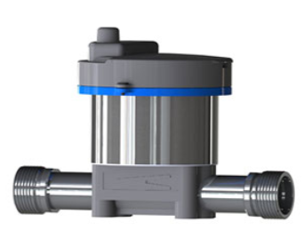

**Spire LoRaWAN Technology**

**SpiRely Commercial Water Meter**

[**https://www.spiremt.com/280W-D-AWWA-residential-water-meter.html**](https://www.spiremt.com/280W-D-AWWA-residential-water-meter.html)

**OneDrop Residential**

**Water Meter**

[**https://www.spiremt.com/280W-D-AWWA-residential-water-meter.html**](https://www.spiremt.com/280W-D-AWWA-residential-water-meter.html)

**Spire Features & Benefits**

Each utility environment presents special technical challenges. That's why Spire OneDrop & SpiRely created two unique applications specific AMI Water Meters to provide optimal communication between the meter, RF network, and the Utility. The OneDrop and Spirely Water Meters easily migrate between drive-by and fixed network modes to ensure reliable meter reading operations regardless of network status. By automating routine tasks and operations, utilities gain efficiencies and can provide an enhanced customer service experience to all clients.

• Seamless, smart sensing network architecture provides a flexible, cost-effective network rollout by and base station.

• Redundant Operating Modes for enhanced system reliability.

• Smart sensing algorithms automate and improves communications.

• Data redundancy in the Family of water meters, with built-in storage of 72 hourly reads.

Seamlessly Migrate Between AMR & AMI

• Near Real Time Alert Monitoring ensures responsive customer more service. Near Real Time Alert Monitoring ensures responsive customer service.

• Remote Firmware Upgradability protects today’s investment and allows the AMI Water Meters to grow with future technology

• End-to-End Encryption for secure, protected data transmission privacy

• Anytime Network Commands puts the utility in touch with field assets.

• Flexible transmission interval scheduling with either every 12 hours, or once per day (for automatic communication between the endpoint extended battery performance).

• 15 Minute consumption granularity reading.

Plug and Play Design

Two Way communications

With a need to respond immediately to the shifting priorities of a fast paced water utility, the OneDrop& Spirely Water Meters AMI Fixed Network incorporates advanced end-to-end true 2-way communication. The system operates on a secure, encrypted, channel and time specific proprietary protocol. The Time Asynchronous RF Protocol operates by assigning each Meter a specific time slot to listen for the Gateway. Because of this efficient Spread Spectrum design, IP packet collisions are all but eliminated offering increased reliability and better performance

• The Lowest power Radio technology to ensure long life providing utilities with reliable reading year after year

• On Demand Reads for accurate, remotely available answers to billing inquiries.

• The Lowest Latency Response Time to empower utility personnel with timely information for their customers.

.

.

.

2

**Spire LoRaWAN RF  OneDrop and SpiRely**

Spire LoRaWAN Water Meters are Proactive, Preemptive, and Intuitive We engineer our meters complex installation procedures just to move forward with technology migration. OneDrop and SpiRely Water Meters installation is quick and painless, reducing costs while requiring little to

no technical expertise.

• Automatic Network Communication for immediate startup and implementation

• Meters are available pre-configured at the factory for immediate deployment

• Ultra-compact form factor provides an elegant quality design minimal footprint and no opportunities to tamper with the meter.

• Fully integral LORAWAN design requires no installation administrative integration of installation data of antennas or connection to encoder registers* for quick deployment.

**Moving At the Speed of Technology**

Spire OneDrop & SpiRely is a high-service solutions provider specializing in advanced digital water metering, data delivery, and Utility Intelligence (UI) software. Spire OneDrop & SpiRely’s family of new and innovative smart water technologies continues to expand Smart City strategic plan. Join us in support of today’s dynamic water utility business environment, and the water department’s rapidly evolving role within metering technology.

**Architecture**

The simplicity found in nature inspired the overarching architectural design for OneDrop and Spirely Water Meters and SpireCapture. Maximizing OneDrop and Spirely Water Meters’ RF footprint through efficient use and design of network components, while synchronizing communication between Water Meter and collector result in today’s most cost-effective and efficient AMI system available. SpireCapture software enables utilities to clearly visualize the robust, detailed consumption information delivered through the OneDrop and Spirely Water Meters network. Together, OneDrop and Spirely Water Meters and SpireCapture allow the utility to analyze, manage, and precisely account for system-wide water consumption. Smartly designed smartphone apps and web portals create an interactive customer engagement that improves customer satisfaction, reduces calls to City Hall, and empowers the ratepayer to responsibly and confidently make informed decisions about their personal usage

.

ARCHITECTURE

3

*www.spiremt.com*

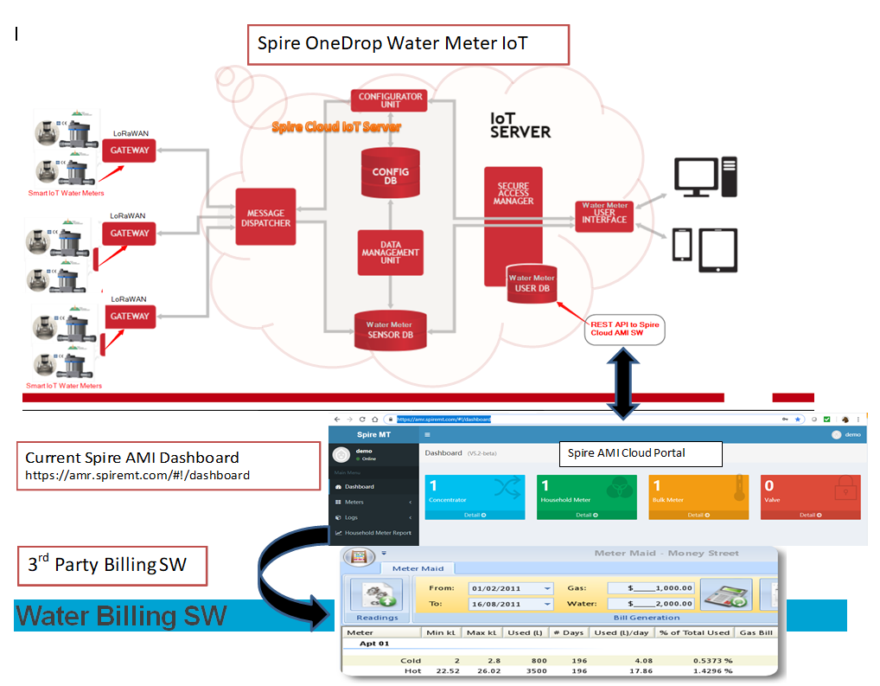****

**Specifications/Dimensions**

Found Here

[https://www.spiremt.com/pdf/Datasheet_OneDrop_Residential_Water_Meter.pdf](https://www.spiremt.com/pdf/Datasheet_280W-D_EN_17-1027.pdf)

[https://www.spiremt.com/pdf/Datasheet_SpiRely_Commercial_Water_Meter.pdf](https://www.spiremt.com/pdf/Datasheet_280W-CI_INTL_2017.07.08.pdf)

**Spiremt.COM**

**Address**

249 Cedar Hill Street Marlborough,  
MA 01752 USA

**Phone number**

Sales : 1-888-738-0188 (Toll Free)

Support : 1-888-738-0188 (Toll Free), 1-978-263-7100 opt 2

General : 1-978-263-7100

**E-mail address**

Sales : Sales@SpireMT.com

Support : Support@SpireMT.com

General : Solutions@SpireMT.com

4

